

***Holy Cross Nursery School***

**Hand Washing Policy**

This Policy is to ensure that our children, staff, parents and visitors are kept as healthy as possible.

Guidelines recommend that children in early year’s settings are taught the importance of hand washing to prevent the spread of infections.

It is the responsibility of the staff team to ensure the children understand the importance of hand hygiene and the reasons we wash hands. It is also the staff’s responsibility to ensure they lead by example washing hands regularly alongside the children.

We aim to provide a hygienic and safe environment for children and adults.

We aim to educate children about good hygiene practices, through the use of staff modelling, the use of books, puppets, songs, videos and through role play.

Hand washing is the best way to limit the spread of germs.

Staff will support children to wash hands in bathroom when available and will remind and support children to wash their hands at the following times:

**Before and after**

* Snack routine
* Lunch time
* Cooking activities
* Dough play

**After**

* Using the toilet
* Handling animals/insects
* Gardening
* Messy play/mud kitchen activities
* Outdoor play
* Coughing or sneezing into their hands

**Children will follow the actions of Soapy Bear**

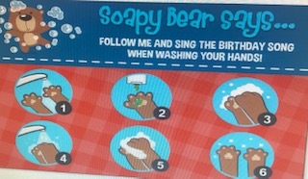

**As well as Soapy Bear, Staff will show children how to wash their hands:**

* Pull up sleeves
* Wet hands
* Dispense soap onto hands
* Rub soap over hands; making sure to wash front and back of hand and in between fingers
* Singing song whilst washing (Baby Shark...)
* Rinse soap off fully
* Shake water off hands
* Dry thoroughly using 1 blue paper towel
* Photographs of correct sequence/order will be displayed in the bathroom

Visuals will be displayed to support children with special needs

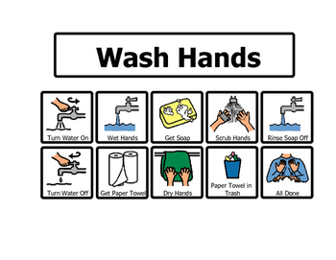Social stories will be read to consolidate the importance of hand washing and support their understanding

