**OCTOBER NEWSLETTER 2020**



4th Theo; 5th Leon, Grace G,

15th Lorcan C; 18th Calab;

27th Lorcan B

**Our topics and themes this month are** - Halloween

Autumn

People who help us

**Our colour and shape focus is** – Orange and Brown

Exploring leaves

**Sponsored Walk - Friday 2nd**

We are so lucky to be able to do our Sponsored Autumn Walk! And thank you for any money you raise for school funds.

Our sponsored walk will take place in Cavehill Country Park. A bus will leave at 9:00am for bubbles RED and BLUE; and 12noon for bubbles GREEN and YELLOW. A couple of things for you to remember:

Children are to be left to the bus at the front of the community centre on Herbert Street.

Make sure your child has been to the toilet before leaving the house as we will not be able to change them inside anywhere if they have an accident

Watch the weather – they may need a raincoat or wellies!

Please return all sponsor money by Friday 9th October.

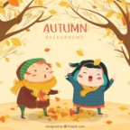

**Shared Education Programme**

We are unfortunately not able to run the program as before; however CRIS(Community Relations in Schools) are very keen to try and organize some fun interactive workshops with parents. If this is something you might be interested in, please forward a message to your teacher via Seesaw. Our shared education parent program enables parents to take part in a wide variety of workshops and courses based on parental interest each year.

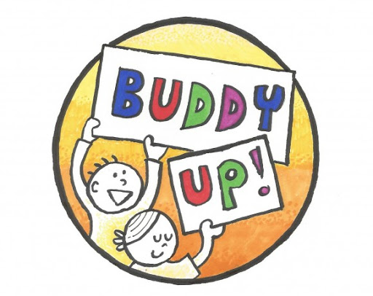

**School Lending Library**

Our school library in association with the Big Bedtime Read project will begin on Monday 12th October; all children can take home 5 books which we would encourage you to read to your child at bedtime each night. The books should then be returned the following Monday where they will then be quarantined for the rest of that week, each second week we will give your child another bag. Mrs Hanna will give out and collect the bags; Mrs Mallon’s class will be done in the morning; and Mrs Murphy’s class in the afternoon.

[](https://www.google.co.uk/url?sa=i&rct=j&q=&esrc=s&frm=1&source=images&cd=&cad=rja&uact=8&ved=2ahUKEwja8aOwz_jkAhX_BWMBHbGAA50QjRx6BAgBEAQ&url=https://www.shutterstock.com/search/children+reading&psig=AOvVaw0T0yb3NCUULCt2m4r4cwW1&ust=1569935426079563)

**Clothes**

Children are going outside to play every day, so please ensure your child has a warm coat with them as the weather is getting colder.

Please make sure your child always has a change of clothes in school. If your child has an accident and we do not have a change of clothes, they will have to go home. Unfortunately we are not allowed to use other clothes. Clothes brought from home must be quarantined for 72 hrs before staff can use them, therefore if your child is prone to accidents in school please make sure there are a number of changes.

To help promote children’s independence, please make sure they can manage their own clothing before and after the toilet. Also some children still have lace shoes – please change to Velcro shoes.

If girls wear skirts they MUST wear shorts or tights underneath.



**School Fund & Dinner**

Schools funds for October is £20 (4 weeks). Dinners costs £2.50 a day. If you are a paid dinner the amount owed will be written on your child’s money bag.

Money bags will be in your child’s tray on Monday morning and **MUST** be paid in full by Friday 9th.

If your child is a paid dinner and off school during the month, money will be refunded to you at the end of October.

**Settling in meetings**

**14nd 18th –**Mrs Mallon and Mrs Murphy will arrange a phone with you to discuss how your child has settled into nursery. These calls will take please after 1pm each day. Nearer the time, you will be able to choose a day or time which suits best.

**Mid term Break**

School will be closed from Wednesday 28th – Tuesday 3rd November.

School reopens on Wednesday 4th November.

**Covid-19**

Everyone is aware, of the 3 main symptoms of Covid-19 and children must be kept home if presenting with any of them. Children are allowed to come to return to school with either a negative test result or 14 days clear of symptoms. Children are allowed in school with a runny nose or common cold – but ONLY if they are well enough to be in school and are able to attend to their own personal needs. Staff cannot be expected to clean noses during the pandemic.

**Halloween Hooley** - **Tuesday 29th**

Children can come to school dressed up for Halloween, but unfortunately we cannot allow any accessories; for example wigs, hats, broomsticks, swords etc… We will have a fun morning of games and activities. There is no school dinner on this day so children will finish school at 11.15am – RED and BLUE bubbles

11.30am – YELLOW and GREEN bubbles



Please keep teaching your child self help skills like cleaning their nose, pulling up their sleeves, washing their hands and covering coughs and sneezes with their elbow.

