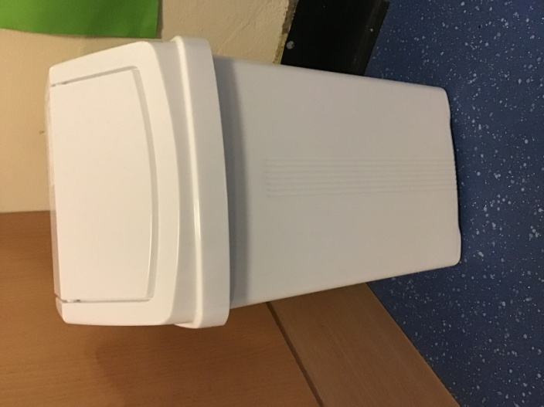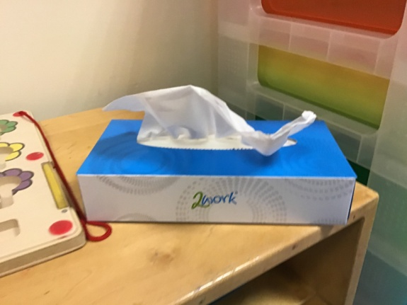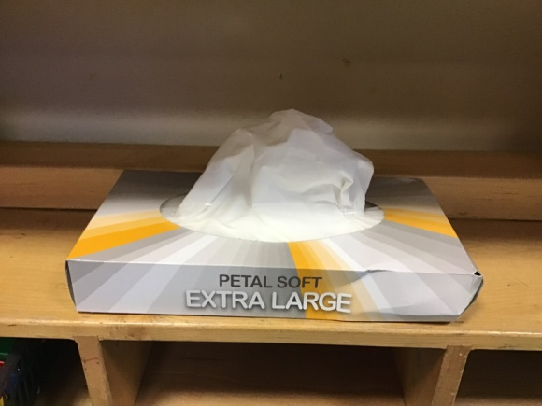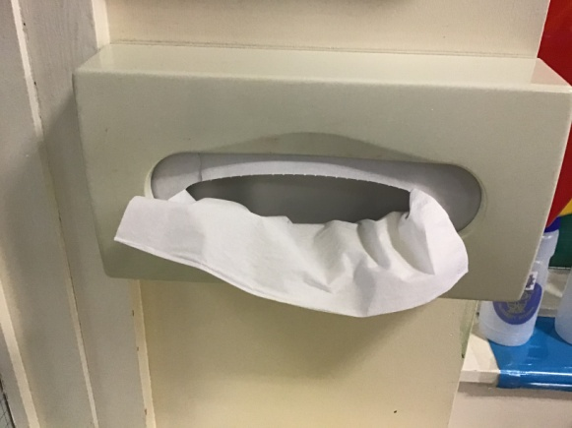

We have lots of tissues and bins in our classroom.

If you have a runny nose or sneeze, you can get a tissue.

It is really important to put the tissue into a bin afterwards.

When we come into school we wash our hands with soap and water.

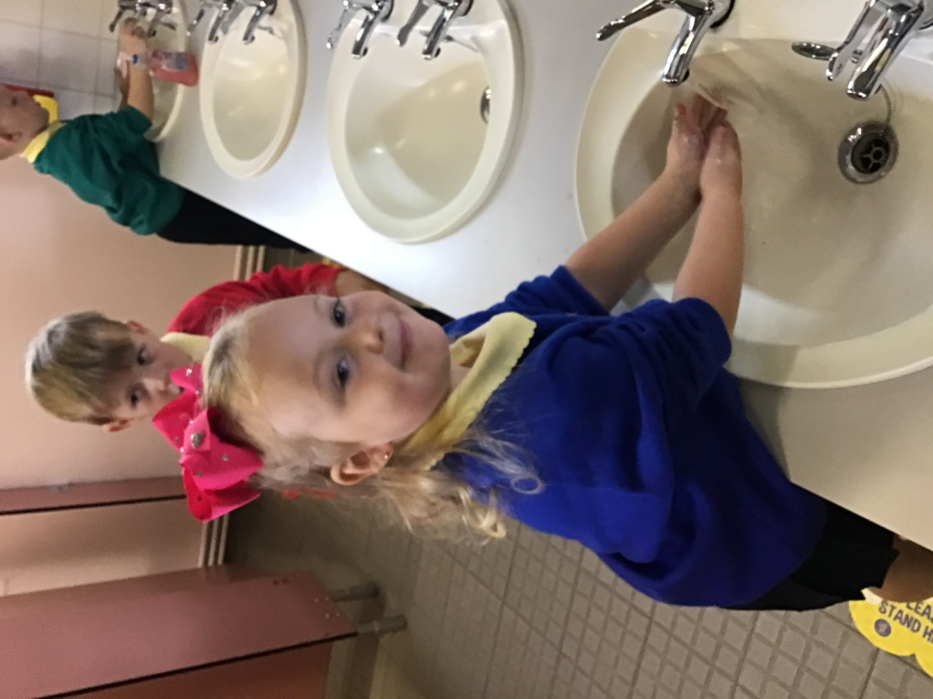

We have to wash them really well. The Baby Shark song helps to remind us to wash the different parts of our hands.

Now our hands are nice and clean and have no germs.

Sometimes in school you might need to sneeze or cough.

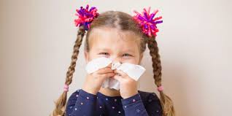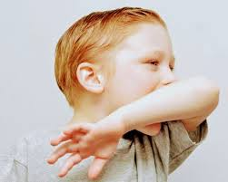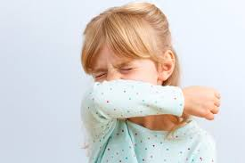

You might have a runny nose and need a tissue.

It is really important to do this into your elbow. This stops any germs spreading to toys or your friends.

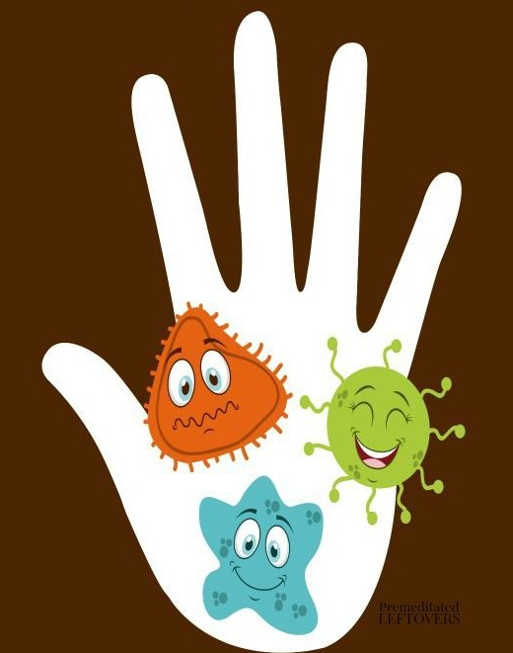

Our hands can have lots of germs that we cannot see.

Some germs can spread very easily and make us sick.

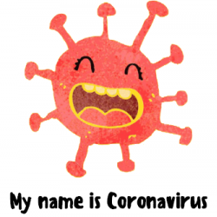

We can do lots of things in school to stop us from getting sick

We are happy in school playing with friends and having fun

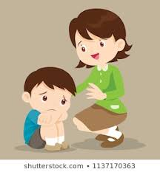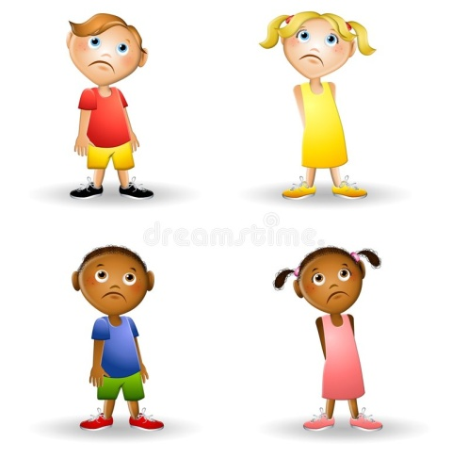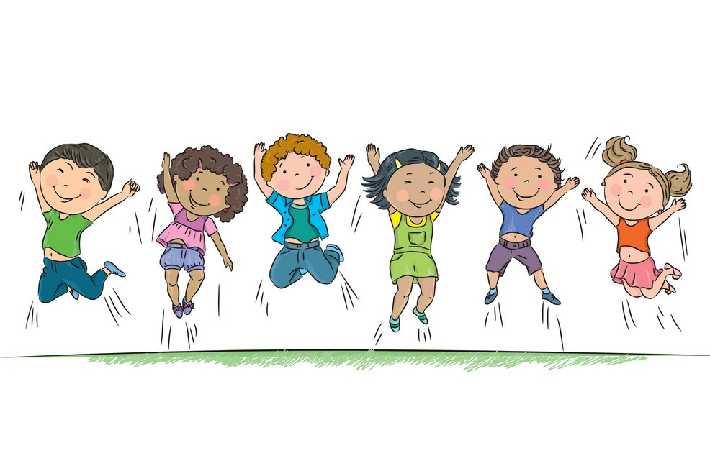

If you are sad you can talk to the teacher. She will show you different ways to make you feel better.

But sometimes we can feel sad and this is ok.

Some things in school we cannot share.

Everyone has their own sand and dough box. Just look for your symbol.

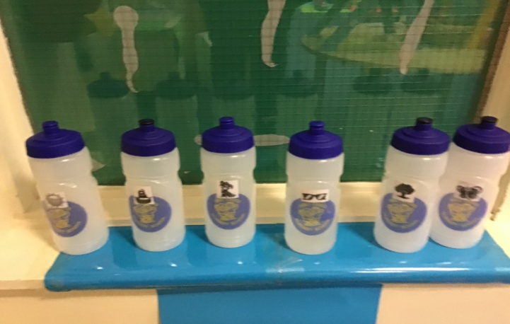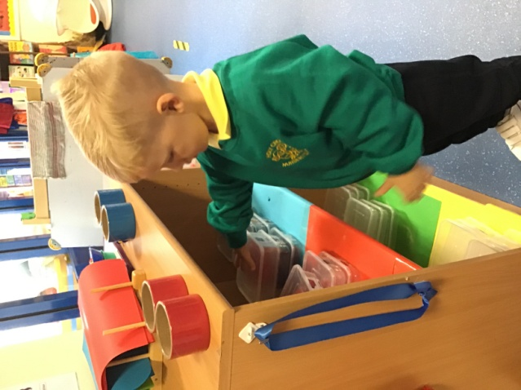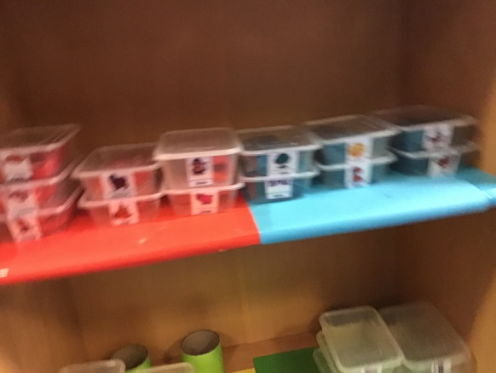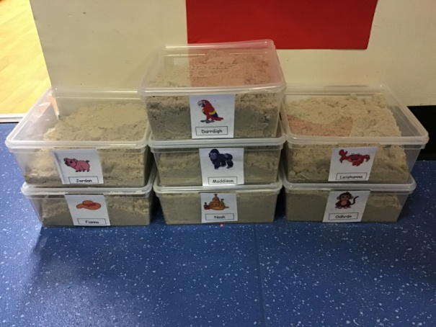

Your own water bottle

Don’t forget to put it away when you are finished.

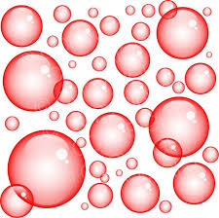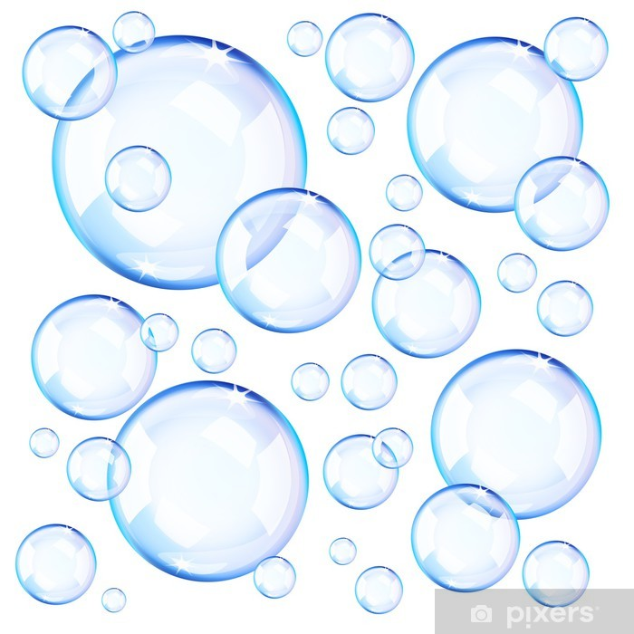

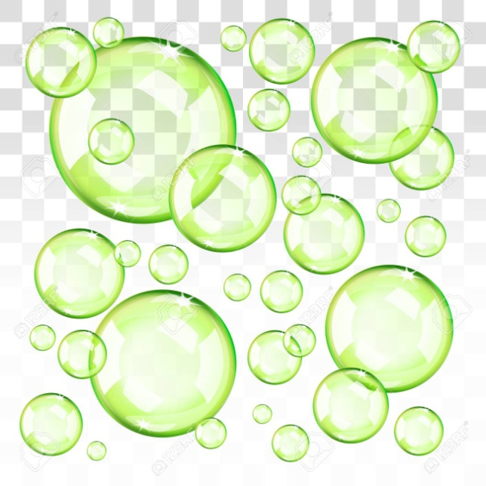

Snack bubble

Dinnertime bubble

Circle time bubble

Storytime bubble

Boys and girls have a special colour bubble.

Some are red, blue, green or yellow.

There are lots of floor markings in school.

When we go outside we line up on a floor marking.

When we go into the quiet room or the hall we have to sit on an **X**

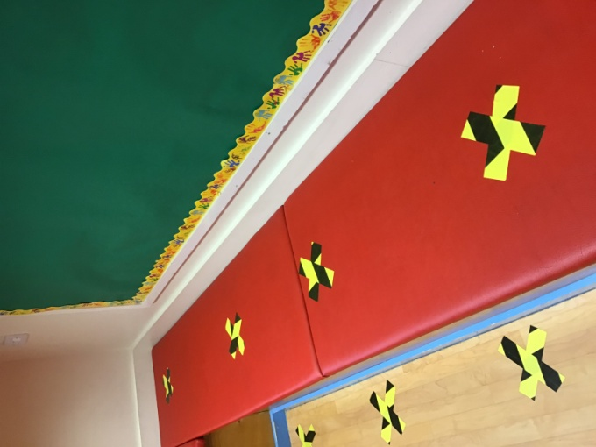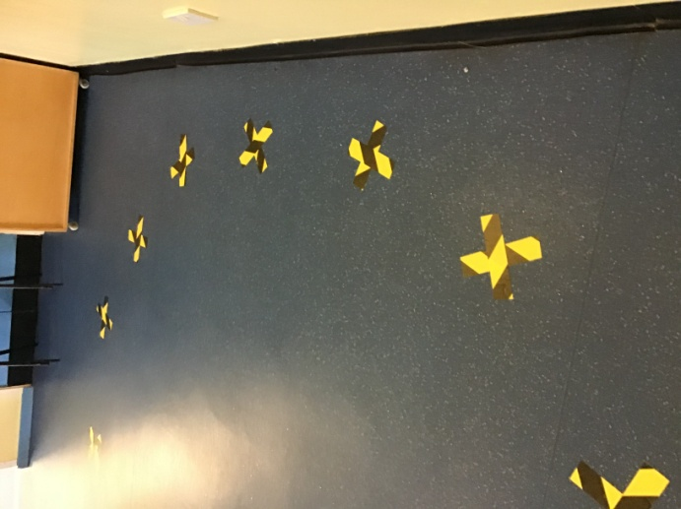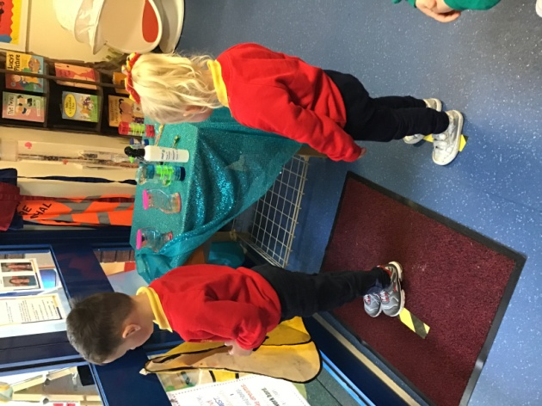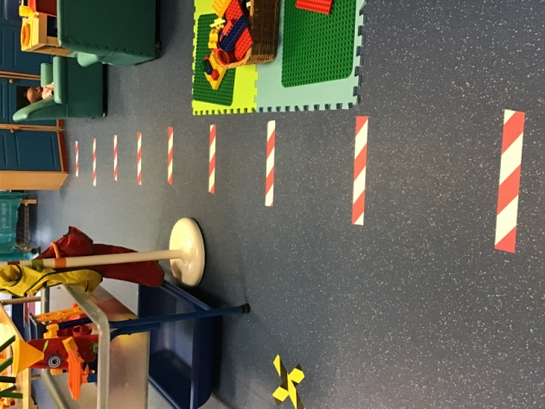

Boys and girls will have lots of fun playing together.

We have new ways of saying hello to our friends.

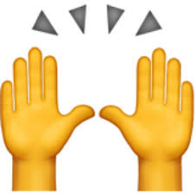





We save all our hugs and kisses for home.

Wave

Smile

Thumbs up

Air high five

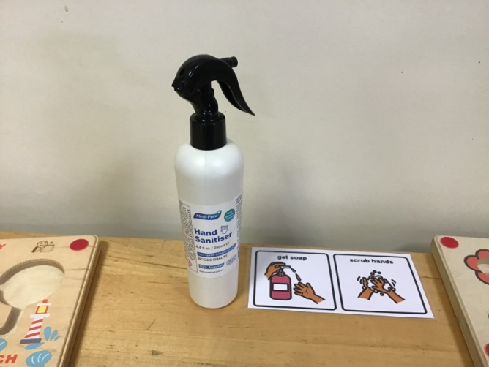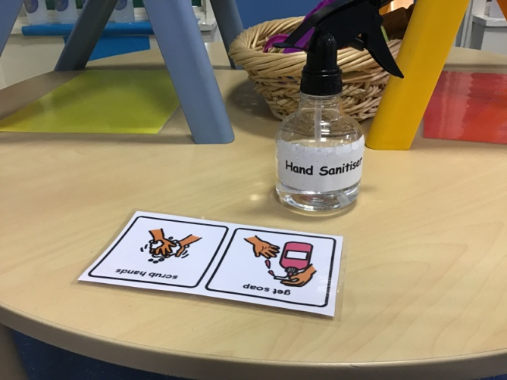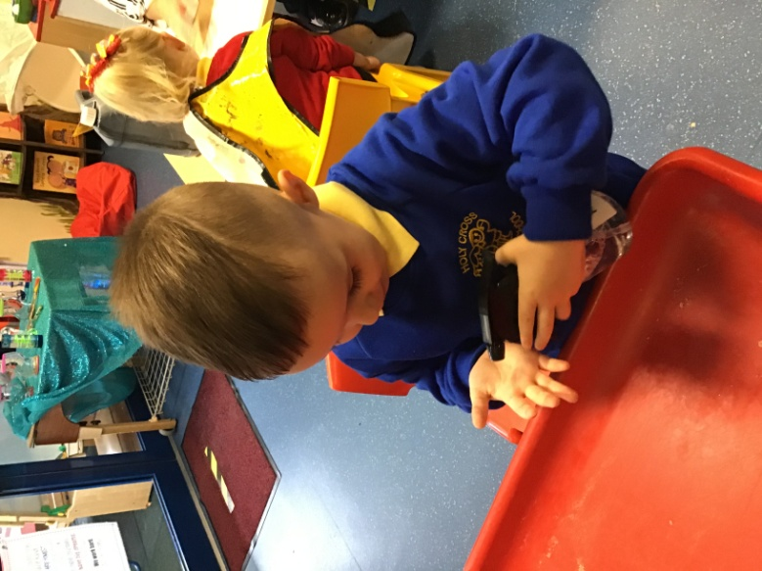

Just like this

We must sanitise our hands when we go to a different play table.