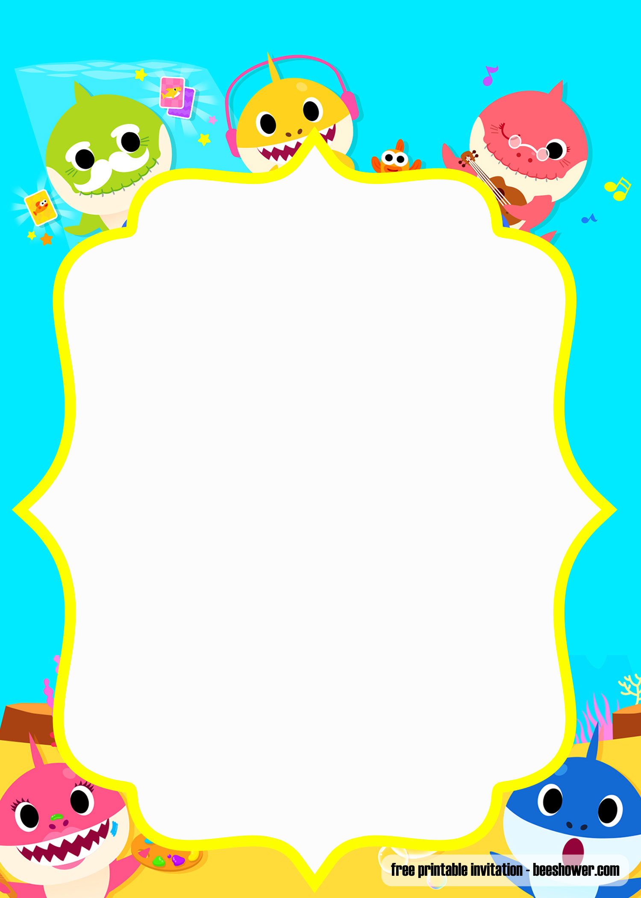

**Wash your hands dodododo**

**Wash your hands dododo**

**Wash your hands**

**Lots of soap dodododo**

**Lots of soap dododo**

**Lots of soap**

**Fingers first dodododo**

**Finger first dododo**

**Fingers first**

**Now your thumbs dodododo**

**Now your thumbs dododo**

**Now your thumbs**

**Top and bottom dodododo**

**Top and bottom dododo**

**Top and bottom**

**Nice and clean dodododo**

**Nice and clean dododo**

**Nice and clean**